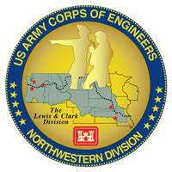
Columbia River System (CRS) Fish Facility Design Review Work Group (FFDRWG)

USACE, Portland District (NWP) and Walla Walla District (NWW)
  - November 2023 Meeting Notes
Meeting Date: November 8, 2023, 09:00-12:00
FFDRWG Meeting Files:
https://pweb.crohms.org/tmt/documents/FPOM/2010/FFDRWG/FFDRWG.html

Introductions
BPA
Scott Bettin
Christine Petersen
Greg Smith
Leah Sullivan
Ben Hausmann
Carolina Andes
NOAA
Blane Bellerud
Gabriel Brooks
Trevor Conder
Claire McGrath
Kelsey Swieca
Chris Magel
Kinsey Frick
Dana Bethea
USFWS
Dave Swank
Shelby Fowler
Joe Skalicky
States
Erick Van Dyke (ODFW)
Ben Clemens (ODFW)
Charles Morrill (WDFW)
Jonathan Ebel (IDFG)
CRITFC/Tribes
Tom Lorz (CRITFC)
Laurie Porter (CRITFC)
Greg Silver (CRITFC)
Casey Baldwin (CTCR)
Michael Karnosh (CTGR)
Lawrence Schwabe (CTGR)
Torey Wakeland (CTGR)
Aaron Jackson (CTUIR)
Ralph Lampman (YN)
Tod Sween (NPT)
NPCC
Kris Homel
FPC
Erin Cooper
Noah Campbell
PSMFC
Alan Brower
Darren Chase
Roger Clark
Mark Leonard
Scott Livingston
Nicole Tancreto
Don Warf
CENWD
Doug Baus
Tim Dykstra
Dan Feil
Cindy Studebaker
Lisa Wright
Sean Tackley
Ian Chane
CENWP-PM
Ida Royer
Erin Kovalchuk
Brad Eppard
Nathan McClain
Jake Macdonald
Jon Rerecich
David Trachtenbarg
Scott Fielding
Rebecca Cates
CENWP-OD
Andrew Derugin
Jeanette Flemmer
Tucker Gossett
Bob Cordie
Jeffrey Randall
Eric Grosvenor
Michael Lotspeich
Laura Rickets
Noah Campbell
Tammy Mackey
Robert Wertheimer
Patricia Madson
Darren Gallion
Kyle Tidwell
CENWP-ENC
Adam Jones
Adam White
Brandt Bannister
Shari Dunlop
Chris Motti
Steve Schlenker
Max Wilson-Fey
Collin Porter
Dan Penn
Aaron Litzenberg
Mehdi Roshani
Cole Marfise
CENWW-PM
Chuck Barnes
Steve Juhnke
Steve Sipe
Ricardo Walker
Brad Trumbo
Liana Aker
Michael Erickson
CENWW-OD
Chris Peery
Denise Griffith
Elizabeth Holdren
Ken Fone
Bobby Johnson
Deb Snyder
CENWW-ENC
Jon Renholds
Sean Milligan
Ryan Pestes
Travis Foster
John Lomeland
Ryan Laughery

Action items from previous meetings

Chuck will provide presentation at November FFDRWG outlining path forward for LSR hydraulic cylinder installations
- Chuck will provide presentation at *December* FFDRWG outlining path forward for LSR hydraulic cylinder installations

NWP Topics for FFDRWG Update/Review/Coordination

NWP BON2 floating adult lamprey trap for tribal translocation (*partner project; not a USACE design) – Ralph Lampman (TL), Jake Macdonald (FFDRWG)
- See attached ‘Lamprey Floatable Collector Photos and Needs.pdf’
- Proposing modifications to the mesh screen to provide larger openings for lamprey
- Sea lion exclusion will be accomplished with a pipe & wire fence. Does it need to extend over the pontoons? Brooks: Fence should extend as far out as possible. How high does it need to be? Ask Tidwell?
- Ralph wants to modify mesh to create wide entrances, like a lamprey orifice. Conder does not like the 2”x 2” mesh dimensions. Can make the spaces as wide as you want, but keep them <=1.5” high.
- Bonneville WA shore is preferred location, TDA is second choice
- Need an upwelling box/collection tank.
    - Grosvenor: John Day has the old collection tank from the NFL LPS and other surplus tanks available, Eric will send pictures.
    - Macdonald: The Cascades Island lamprey trap hasn’t performed great the last few years, could we use that tank for testing?
- Gossett: How do you deal with mortalities in the system?
    - Lampman: Experience with 4” tubes has been that morts flush out
- Cordie: How is it anchored? Need taglines to the shore?
    - Lampman: Yes need anchor points and taglines (ACOE would know best for how and where)
- Conder: Can’t shut down a ladder to service the trap.
- Lampman: Testing in the hatchery will start in March, planning 1 month of testing and ready to deploy by April.
- Baus: Special operations needed to install or operate the trap? If you anticipate them, be sure to coordinate with FPOM.
- Flemmer: How flexible will this be for changing tailwater?
    - Lampman: flexible tube running up the bank.
- Derugin: Anchoring system needs to be designed by a District PDT
- Cordie: How frequently is access needed?
    - Lampman: Access to the collector is not needed (it will be a system set up and ready to go) unless there are emergencies (but in those case it may be easier to pull it out and fix rather than try to access it on the water to fix, etc.). The collector has 4" flexible tube attached and lamprey will go through the tube to a trap box secured on dry land (bank or top of the concrete).
- Cordie: Would it have a dock to the shore? (Shore access would require some prep work)
    - Lampman: I don't think a dock is needed for deployment, but ACOE would know best what route is best for deployment.
- Cordie: How and who will monitor its operation?
    - Lampman: I assume collecting of lamprey would be done by CRITFC but likely need help from ACOE on some basic operation issues (deployment, troubleshooting placement, etc.).
- Cordie: Does it need access by boat?
    - Lampman: No.
- Cordie: Require crane support?
    - Lampman: ACOE is best to answer this. You can see the structure at Bonneville Hatchery.
- Cordie: Is it exempt from the 100’ boundary from a fishway entrance? (FPP section 2.1.1.)
    - Lampman: If it is not interfering with salmon passage, seems like it would be exempt (but need ACOE guidance).
- Cordie: How will safety be addressed? (Will require an Activity Hazard Analysis.)
    - Lampman: Again ACOE will need to guide us through this - but if we are not accessing it on water and not adjusting the position regularly, the risks are low.
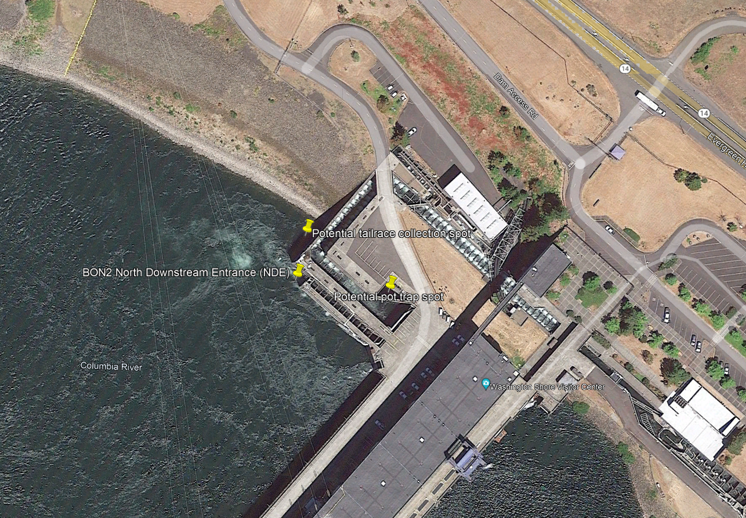
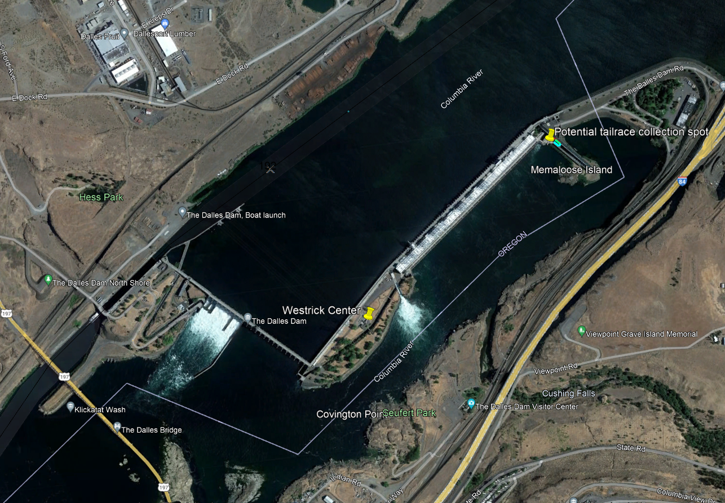
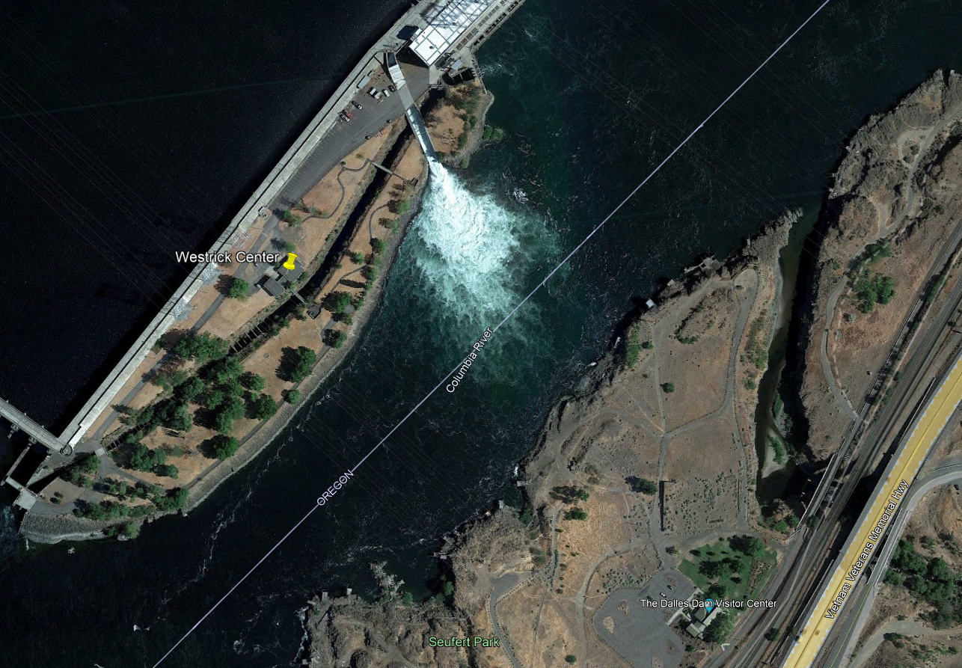
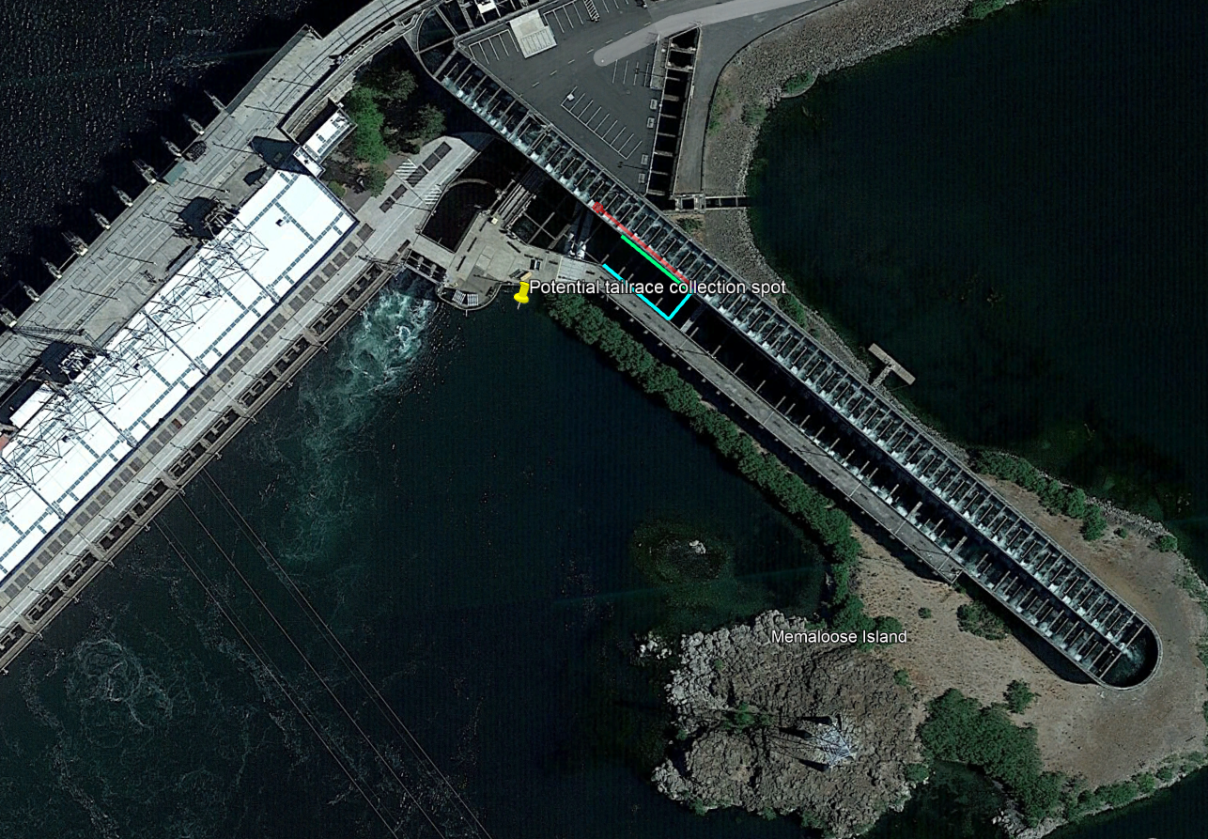

NWP BON Spillway rock mitigation – Erin Kovalchuk (PM), Adam Jones (TL), Rebecca Cates (FFDRWG)
- CFD modeling will be used for additional hydraulic loading analysis to confirm the deadweight anchor requirements for the barriers. 60% DQC and FFDRWG review will occur once this is complete.

NWP BON PIT Detection – Erin Kovalchuk (PM), Marina Riley-Collette (TL), Jeanette Flemmer (FFDRWG)
- PSMFC has submitted a new design for the fixed gates, looks “good” at first glance. PDT is ramping up to review the new design.
- Current review project is for 1 fixed gate, ask BPA about auto gates.
- Hausmann: Could we install outside the IWW? Corps review may not be done by this Winter. Whole sluiceway would need to go down. Conder: Not in the Spring.
- Morrill: Assess how much time it would take and reevaluate later. If it’s a short outage, maybe we could consider it.

NWP BON2 FGE – James Smith (PM), Max Wilson-Fey (TL), Jon Rerecich (FFDRWG)
- Construction completed with all B2 units modified. Working with PNNL to develop and implementation plan for a post construction evaluation starting in spring of 2024.

NWP TDA Backup AWS debris management – Erin Kovalchuk (PM), Mehdi Roshani (TL), Jon Rerecich (FFDRWG)
- EDR is complete. District PDT resourcing for starting the DDR is underway.
- Conder: Late stage comments are being discussed with Rerecich and Cates. Serious reliability concerns.
- Lorz: haven’t seen details on the floating debris boom alternative.
- Van Dyke: Is the O&M tail being considered at this stage of design?
    - Rerecich will advise where O&M considerations are discussed in the TDA Backup AWS debris management EDR.

NWP BON1 adult lamprey passage improvements – Erin Kovalchuk (PM), Adam White (TL), Jake Macdonald (FFDRWG)
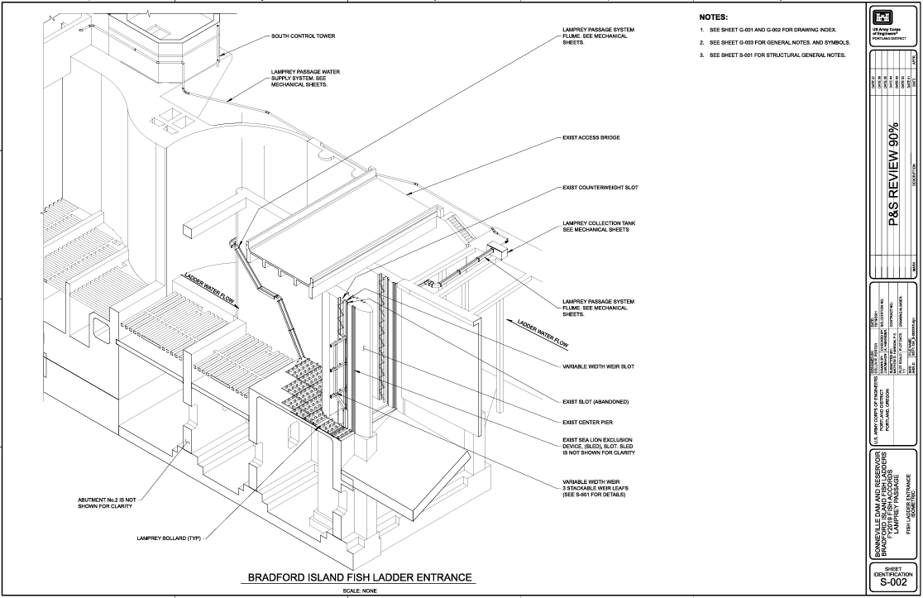

NWP BON2 control section redesign – Erin Kovalchuk (PM), Adam White (TL), Jake Macdonald (FFDRWG)
- Jake will post 90% Plans & Specifications to FFDRWG meeting files for those interested.
- 90% Plans & Specifications “plan-in-hand” meeting (Corps PDT) is scheduled for this afternoon (9/8)
- Need to award contract by 8/1/24. Adam White’s hypothetical (draft/do not cite) schedule to achieve that award milestone:
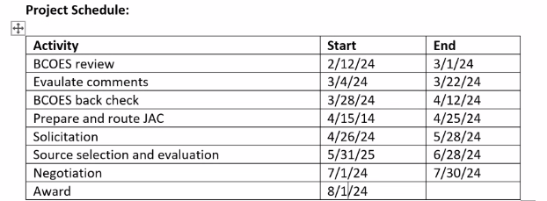
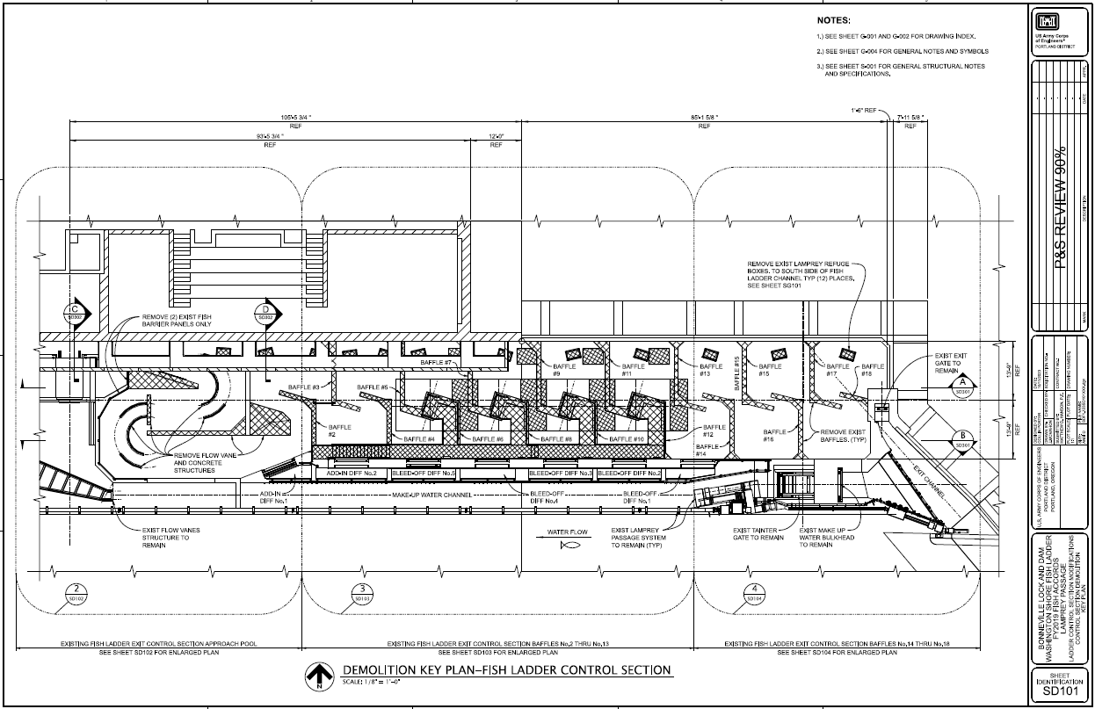
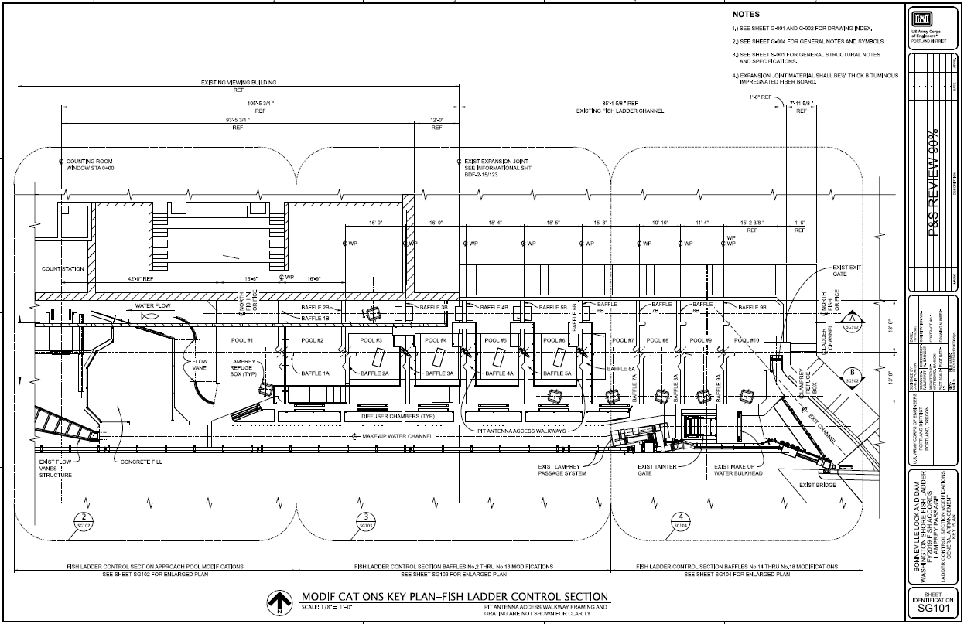
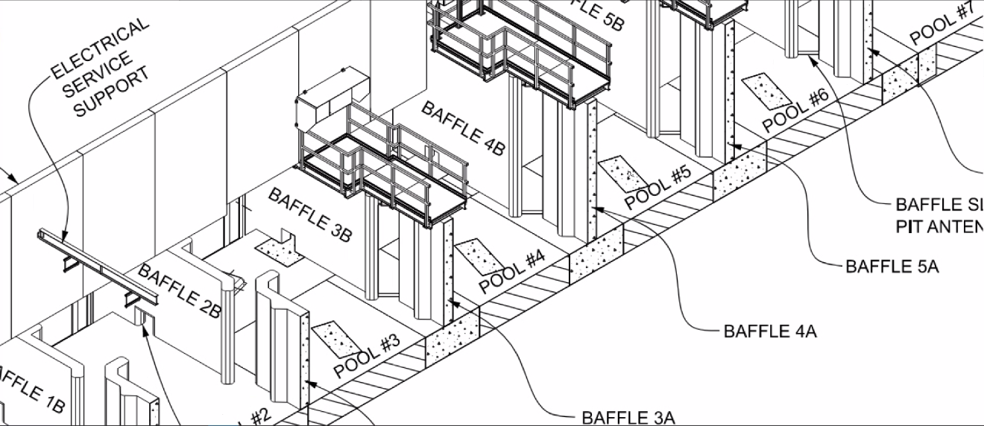
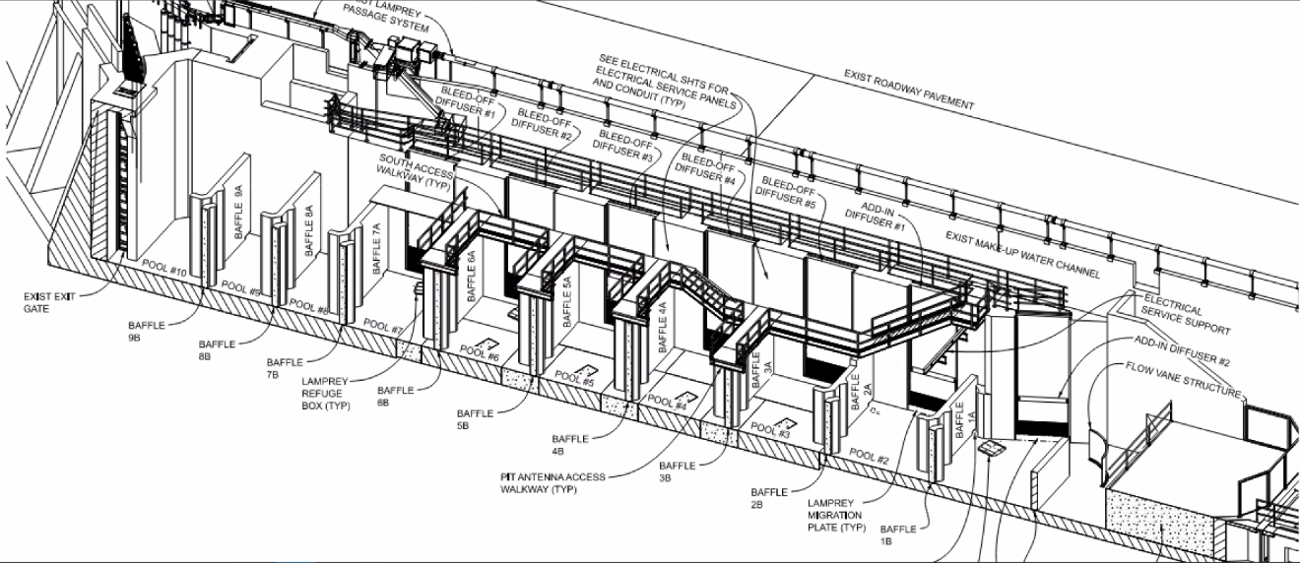

NWP TDA adult lamprey passage improvements – Erin Kovalchuk (PM), Adam White (TL), Jake Macdonald (FFDRWG)
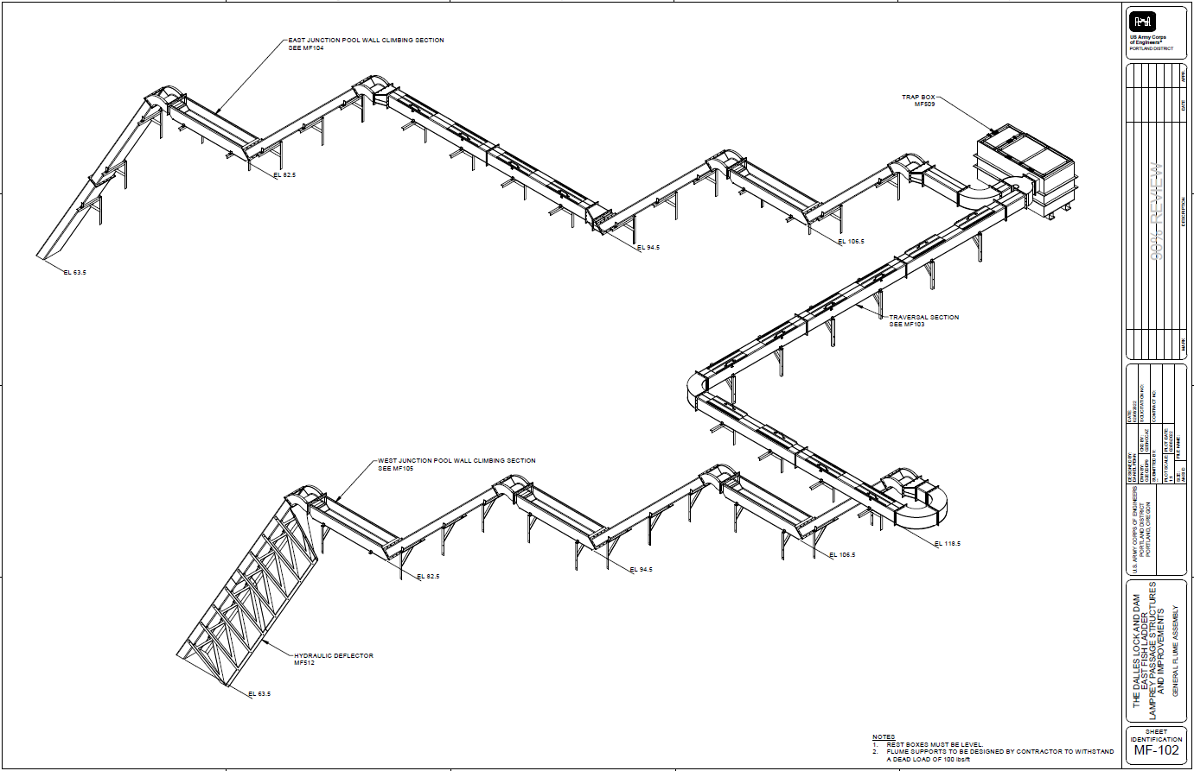
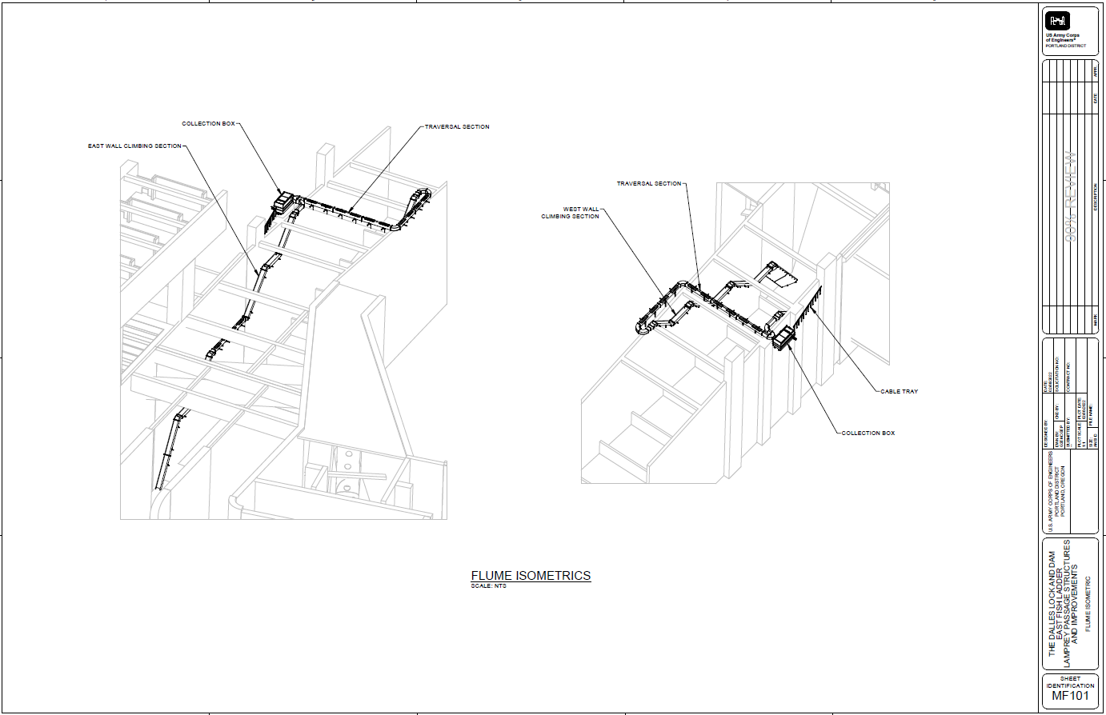

NWP JDA adult lamprey passage improvements – Erin Kovalchuk (PM), Adam White (TL), Jake Macdonald (FFDRWG)
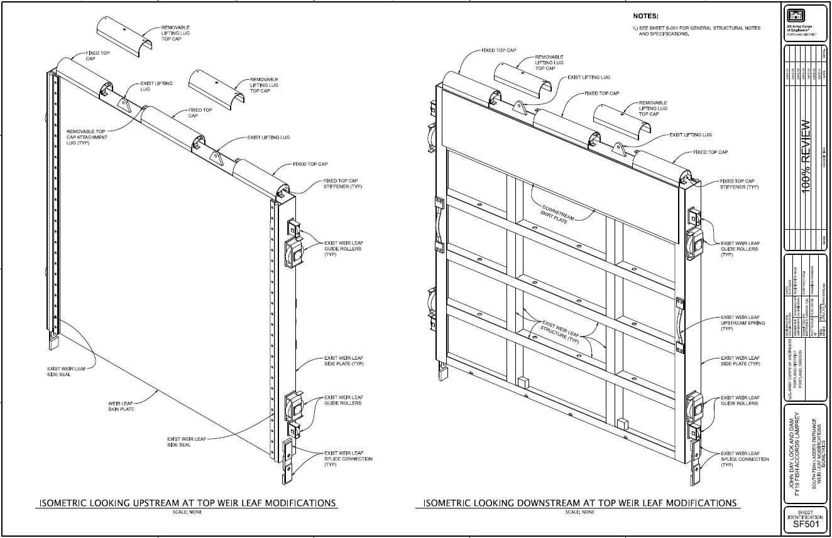
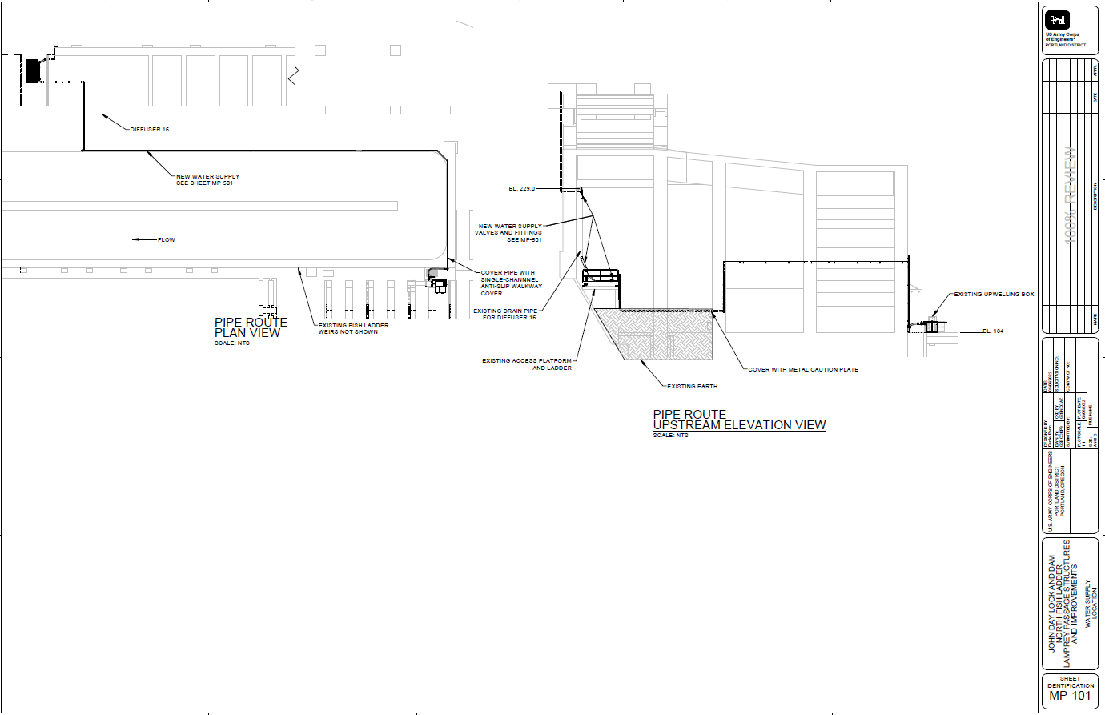

NWW Topics for FFDRWG Update/Review/Coordination

NWW IHR Turbine Unit Cooling Water Exclusion Structure- Steve Juhnke (PM), Liana Aker (Bio)
- No update. Still determining which unit, either unit 2 or 6.
- Conder: Testing in units 1-3? Would prefer unit 2 so it’s in one of the tested units.

NWW MNA Turbine Replacement Design – Jean Desjarlais (PM), Jon Renholds (TL)
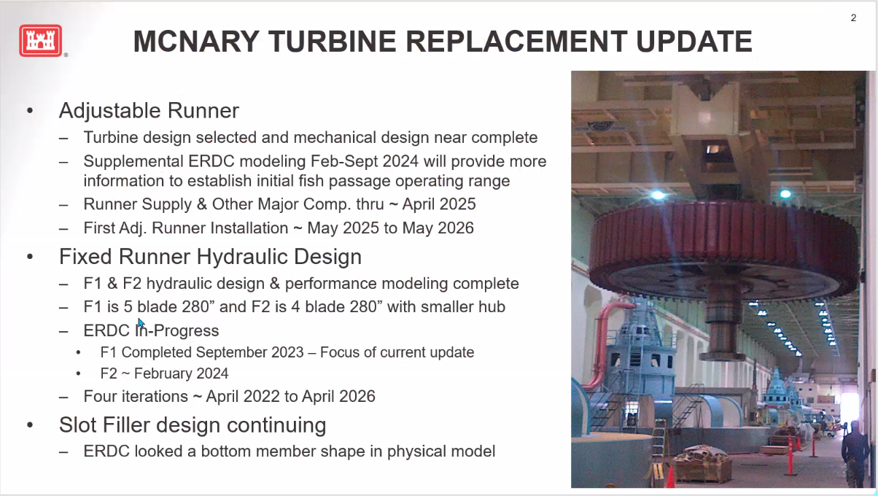
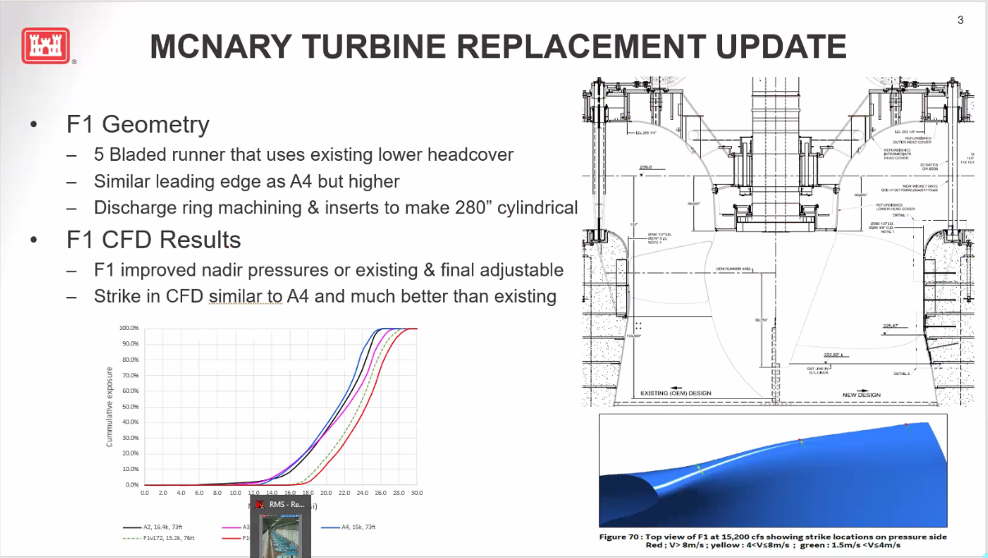
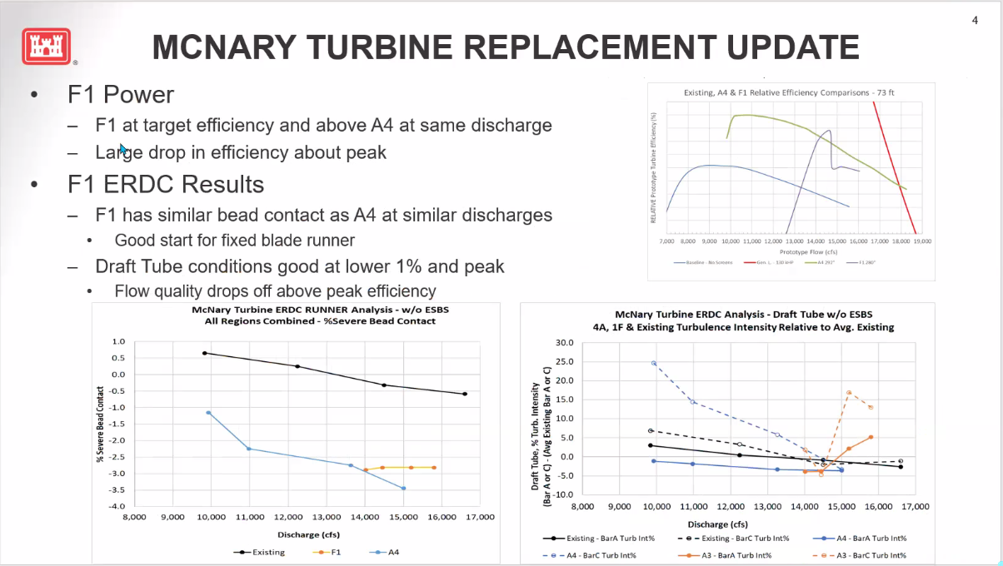
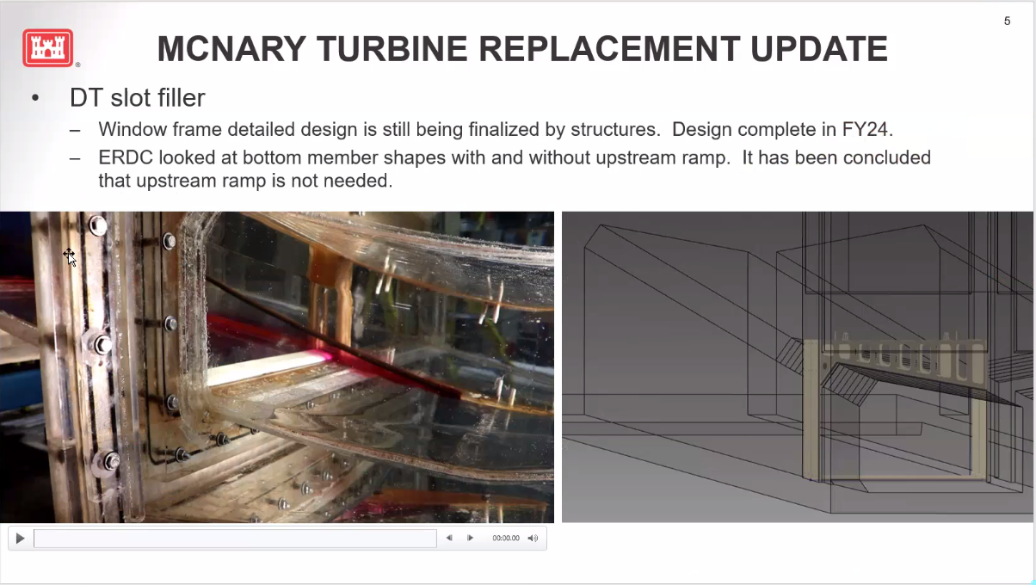
- Replacing all the turbines at McNary with 8 fixed blades and 6 adjustable
- Van Dyke: Does the difference between 4 and 5 blade change amount of water in the draft tube? There is no difference between the two turbine designs for water in the draft tube.
- Lorz: How will these graphs change when ESBS’s are in place? We have looked at a few tests with ESBS’s installed but focus is for design to be without ESBS’s but to check with and without in the analysis. For final design we will have a more with screens data but so far with screens and without screens have very similar ERDC model results. Focus of the design effort is mostly without screens because there are very few fish going through the turbine when screens are in place.
- Conder: How do you go into negative percent bead contact? The graph is averaged around zero and graph shows deviation from existing runner. The Y axis for runner bead contact was incorrectly labeled.
- Conder: Nadir looks good but will the nadir be affected by increasing efficiency? Efficiency drop on graph should not affect pressures much, the efficiency drop is in the draft tube. Also the CFD assumed that efficiency drop did not occur with the fish passage operating range.
- Andes : Is this a mixture of existing turbines and new designs? The project will install new runners in all 14 units.
- Lorz: Will reduction in spill capacity affect design scheduled? Planned to start one unit in 2025 and then take out 2 units at a time. Preparatory projects are occurring now and may be a bigger concern with powerhouse capacity.
- Lorz: Plan to have no more than 2 units out at a time? Two units will be out at a time for turbine replacement. There may be other projects at MNA that have units out at the same time. If we are going to wait 10 years for new hoists, we could wait longer for new turbines. Currently there are no plans to slow down turbine replacement.

NWW LGA Adult Ladder Cooling Chimney Flap Gate- Steve Juhnke (PM), Chuck Barnes (Bio)
- Hopeful it will get installed this winter, schedule is tight, may slip to next winter.

NWW LLA Adult Ladder Turn Pool Gate- Greg Linklater (PM), Chuck Barnes (Bio)
- Awarding contract in FY24 for installation Winter 2024-2025.
- Lorz: Did final design get sent out for this? Chuck sent to group 11/13/2023.

NWW Lower Granite cooling pumps – Steve Juhnke (PM yet to be determined)
- No update. No funding currently.
- Conder: What is the concept we are talking about doing?
- Conder: this should be a priority; we are seeing behavioral issues and delay in ladder. Through one funding avenue, we need to move more quickly on this one.
- Lorz: Want to make sure this is on the SCT spreadsheet so we can track the funding and move forward if additional funds become available.
- Morrill: Is this project really costly enough that it will be a funding issue? Also thinks this should have a higher priority.
- Chuck will investigate the Lower Granite cooling pumps scope of work and report back.
- Peery will add Lower Granite cooling pumps to FPOM agenda.
- Barnes/Royer will add Lower Granite cooling pumps to SCT agenda.

NWW MCN Avian deterrence – Steve Juhnke (PM)

NWW MNA PIT Detection – Steve Juhnke (PM)
- Lorz: Can the PIT barge be evaluated under this project?

NWW John Day Dam and Snake River Ladder Cooling – Steve Juhnke (PM)
- Contract. PDT is developing a scope of work for the Contractor.

NWW MNA Draft Tube Slot Filler – Jean Desjarlais (PM), Jon Renholds (TL), Chuck Barnes (Bio)
- Structural engineering is still fine tuning the lower structure on the slot filler. It has been concluded that a ramp leading up to the slot filler is not necessary.

Upcoming meetings and field trips

FFDRWG and FPOM will not be combined again in the future

Next regularly scheduled NWW/NWP FFDRWG meeting – Thursday, December 7th @ 09:00
  - Send suggestions for agenda items to Jake Macdonald and Chuck Barnes

Field trips to inspect dewatered fishways during in-water work window (December-January)
  - Bonneville Bradford Island Ladder – Jake will schedule sometime in December
  - The Dalles East Fish Ladder – Jake will schedule sometime in December-January
  - McNary Spillway, McNary ladders. Chuck will schedule sometime when Oregon ladder is down. Loop in the Lamprey committee.
  - Bonneville PIT detection.
  - Send suggestions for additional field trips to Jake Macdonald and Chuck Barnes

Field trip for FFDRWG and Corps-Tribal Lamprey Work Group to see JDA adult lamprey passage improvements in operation
  - Partial day, In-person site visit during 2024 fish passage season – Jake will schedule
  - Jake will schedule

